Name: _____________________________ Date: ________ Period: ____ Mr. Ahearn
How the Earth Was Made: Hawaii
1. This is the story of Hawaii; A mountain chain over ______________________________________ years old.
2. _______ In 1934 Felix Meinesz invented the gravimeter; an apparatus used to measure…
A. air pressure B. light C. gravity D. earthquakes

3. _______The big island is twice the height of Mt. Everest. Everest could fit inside of Hawaii ….
A. 140 times B. 1000 times C. 140 000 times D. two times
4. Mauna Kea is the ___________________________________ mountain in the world at 56 000 feet high.

5. Kilauea is the most _________________________________ volcano in the world.

6. Kilauea could be producing (100,000,000 or 100,000) cubic yards of lava a year. The temperature of lava is about (200 or 2000) degrees Fahrenheit. Circle the correct choice.

7. These volcanoes built the big island of Hawaii. Number them in order from the oldest to the youngest.

_________ Kilauea _________ Kohala _________ Mauna Loa _________ Mauna Kea _________ Hualalai

Conclusion
- Experiments in the 1930’s revealed that the big island is a vast structure stretching (30 or 3) miles down to the sea floor.
- Readings of sulfur dioxide gas reveal that Kilauea produces more (ash or lava) than any other volcano on Earth.
- The Landscape reveals that lava from (7 or 5) volcanoes built the island.

___________percent of the Earth’s volcanoes lay around the edge of the Pacific Ocean. (254 or 452) volcanoes make up the Ring of Fire.

______ Which image below represents a subduction zone?
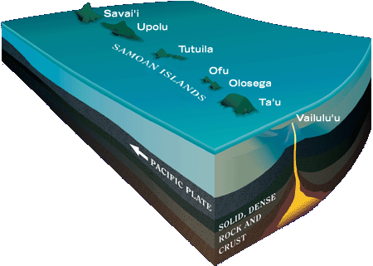
- B. C.
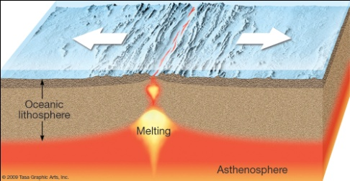
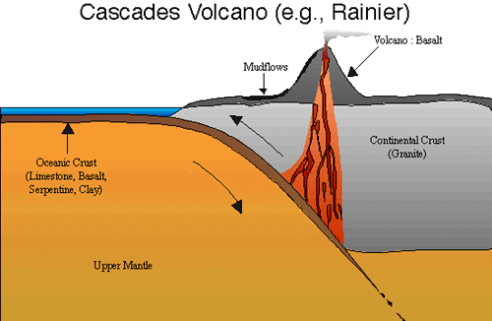

______ Which image above represents a hot spot? (You may have to come back to this question later).

(True or False): The Hawaiian Islands are created at subduction zones.

What is the name for the type of volcanoes found in Hawaii? _______________________________________
(True or False): Basalt lava is the hottest lava in the world and also some of the most fluid (runny).

In the 1950’s the US mapped the sea floor and found a range of mountains under the ocean. These are called (sea ranges or sea horses or sea mounts)
_______ There is a long range of underwater volcanic mountains to the _______ of the Hawaiian Islands.
A. NW B. NE C. SW D. SE

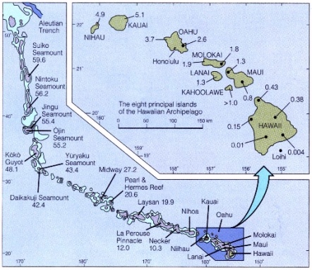
Over (800 or 80) sea mounts and (19 or 9) islands form the sequence known as the Hawaiian _______________________Sea Mount Chain.

Draw an arrow on the diagram to the right showing the direction of increasingly YOUNGER sea mounts in the Hawaiian chain.
J Tuzo Wilson was struck by the fact that:
- The Hawaiian Islands & sea mounts formed a (semi circle or straight line) which are incredibly (common or rare) in nature.
- The further the islands were from the big island the (blacker or greener) they appeared. Greener equals (younger or older).

Wilson used evidence to come up with the theory that Hawaii was created by a _________________________

Wilson’s theory also helped to confirm the Theory of ________________________ _____________________

Why is olivine unusual to see on the surface of Hawaii? ___________________________________________
________________________________________________________________________________________
________________________________________________________________________________________

________ Mantle plumes were the answer to explain:
A. Icelandic volcanoes B. Galapagos islands C. Yellowstone super volcano D. All of these

Explain why the Hawaiian islands are “sinking” below the surface?
________________________________________________________________________________________
________________________________________________________________________________________
________________________________________________________________________________________
________________________________________________________________________________________

What force contributes to the “shrinking” of the Hawaiian Islands. ____________________________________

________ What happened over 1 million years ago to create the long thin shape of Molokai?
A. a meteor impact B. a giant landslide C. a tsunami
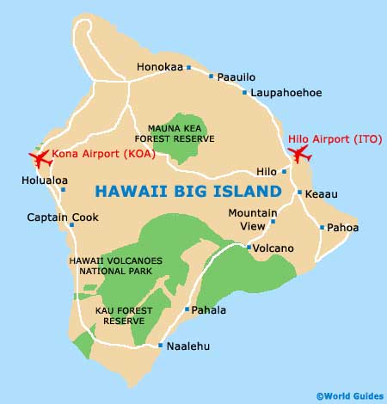
D. an earthquake E. an alien landing
A.
B.
________ What will be the next island in the Hawaiian Island Chain?
A. Luigi B. Lo’ihi
C. Mario D. Lahaina

C.

______ Which letter on the map best shows the location of the next Hawaiian Island?
E.

D.

