Name:   | Period: Date: Lab#____
Lab Title: Air Pressure & Wind speeds

READ THIS:
In this lab we will explore the relationship between air pressure and wind speeds in tropical storm systems.
- We will use real observed data from storms like a hurricane or tropical storm.
- Using the data in the table below, you will create a line graph with 2 Y axis values.
  - The Y axis value on the left side will be Air Pressure (in millibars).
  - The Y axis value on the right side will be Wind Speed (in mph).
  - The X axis will be Date (month/day) and Time (GMT).
- This graph will help you understand the air pressure and wind speed relationship in a tropical storm.
- Please note that, in a tropical storm, low air pressure indicates the strength of the storm. The lowest air pressure indicates the worst part of the storm. Wind is caused by air pressure differences.

Data Table - Hurricane Ike - September 2008 (data source – weatherunderground.com)

Date: | Time: | Lat: | Lon: | Wind (mph): | Pressure (mb): | Storm Type:
09/01 | 15 GMT | 17.60 | -39.50 | 35 | 1005 | Tropical Depression
09/01 | 21 GMT | 17.70 | -40.60 | 50 | 1000 | Tropical Storm
09/02 | 3 GMT | 18.00 | -41.60 | 50 | 1000 | Tropical Storm
09/02 | 9 GMT | 18.60 | -43.10 | 50 | 1005 | Tropical Storm
09/02 | 15 GMT | 18.90 | -45.00 | 60 | 1002 | Tropical Storm
09/02 | 21 GMT | 19.20 | -46.30 | 65 | 996 | Tropical Storm
09/03 | 3 GMT | 19.90 | -47.90 | 65 | 996 | Tropical Storm
09/03 | 9 GMT | 20.60 | -49.60 | 65 | 996 | Tropical Storm
09/03 | 15 GMT | 20.80 | -51.20 | 70 | 991 | Tropical Storm
09/03 | 21 GMT | 21.60 | -52.70 | 80 | 984 | Category 1 Hurricane
09/04 | 0 GMT | 21.70 | -53.20 | 115 | 960 | Category 3 Hurricane
09/04 | 3 GMT | 22.10 | -54.10 | 135 | 948 | Category 4 Hurricane
09/04 | 9 GMT | 22.70 | -55.80 | 145 | 935 | Category 4 Hurricane
09/04 | 15 GMT | 23.20 | -57.00 | 140 | 938 | Category 4 Hurricane
09/04 | 21 GMT | 23.60 | -58.20 | 135 | 945 | Category 4 Hurricane
09/05 | 3 GMT | 23.60 | -59.50 | 135 | 945 | Category 4 Hurricane
09/05 | 9 GMT | 23.70 | -61.00 | 125 | 945 | Category 3 Hurricane
09/05 | 15 GMT | 23.20 | -62.70 | 120 | 954 | Category 3 Hurricane
09/05 | 21 GMT | 22.90 | -64.10 | 115 | 958 | Category 3 Hurricane
09/06 | 3 GMT | 22.60 | -65.60 | 115 | 958 | Category 3 Hurricane
09/06 | 9 GMT | 22.40 | -67.10 | 115 | 962 | Category 3 Hurricane
09/06 | 15 GMT | 21.90 | -68.80 | 110 | 960 | Category 2 Hurricane
09/06 | 21 GMT | 21.40 | -69.70 | 135 | 949 | Category 4 Hurricane
09/07 | 3 GMT | 21.20 | -70.90 | 135 | 947 | Category 4 Hurricane
09/07 | 9 GMT | 21.10 | -72.20 | 135 | 948 | Category 4 Hurricane
09/07 | 15 GMT | 21.00 | -73.40 | 135 | 949 | Category 4 Hurricane
mb = millibars; GMT = Greenwich Mean Time (time at 0° Longitude)
On the map below, use the latitude and longitude values from the data chart above, to plot the path of this hurricane. Connect your dots with a solid line and label it Hurricane Ike.
Staple this page to your lab cover sheet before you hand it in.
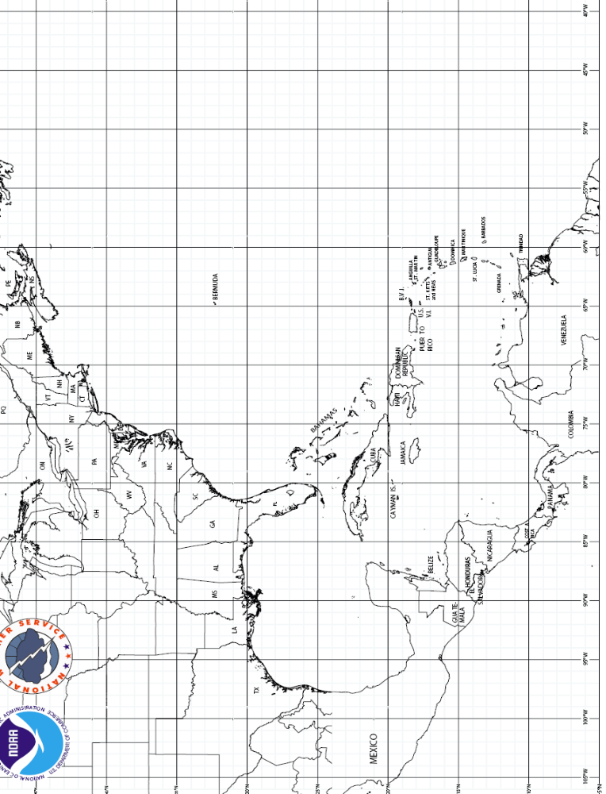

After drawing your graph, look at the pattern of the lines you drew and draw some mental conclusions. Then answer the following questions.

1.___ | A hypothesis is a suggested explanation for an observation. The data table and your graph display a sequence of observations for Hurricane Ike. In a brief but complete sentence, state a reasonable hypothesis to explain these observations.
2.___ | Describe the relationship between wind speed and air pressure within a tropical storm system.  - You must use the units mb and mph in your answer.
3.___ | During a hurricane one of the primary dangers is called a storm surge. Describe a storm surge.
4.___ |   X  Y  Storm Direction | In this hurricane, at which ocean shore location would the highest storm surge most likely occur - Location X or Location Y? Why?
5.___ | See your ESRT for this question. Both millibars (mb) and inches of mercury are units of measure for air pressure. An air mass has air pressure of 1000 mb, using your ESRT, convert 1000 mb to inches (of mercury) and write it below to the nearest 1/100th of an inch.
Base your answers to questions 6 through 8 on the satellite image below, which shows a Northern
Hemisphere hurricane, and on your knowledge of Earth science.
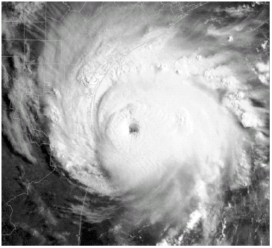
6.___ | What is the usual surface wind pattern around the eye of Northern Hemisphere hurricanes?  (1) clockwise and outward (3) counterclockwise and outward  (2) clockwise and inward (4) counterclockwise and inward
7.___ | Which air mass is normally associated with the formation of hurricanes?  (1) continental tropical (2) maritime tropical (3) continental polar (4) maritime polar
8.___ | Clouds form in the hurricane because the air is  (1) sinking, expanding, and cooling (3) rising, expanding, and cooling  (2) sinking, compressing, and warming (4) rising, compressing, and warming
9.___ | Use your ESRT for this one. When the eye of this hurricane reaches 43° N latitude, this hurricane will most likely be pushed by planetary winds toward the  (1) northwest (2) northeast (3) southwest (4) southeast
10.___ | Which weather change is most likely indicated by rapidly falling air pressure?  (1) Humidity is decreasing. (3) Skies are clearing.  (2) Temperature is decreasing. (4) A storm is approaching.
11A>>>  11B>>> | From the data table for Hurricane Ike, write below the date, time, wind speed and air pressure for the fastest wind speed. Then record the same information for the slowest wind speed.  A. Fastest wind speed answer here>>>>:  Date: _______ Time _______gmt Wind speed______mph Air pressure __________mph
11A>>>  11B>>> | B. Slowest wind speed answer here>>>>:  Date: _______ Time _______gmt Wind speed______mph Air pressure __________mph

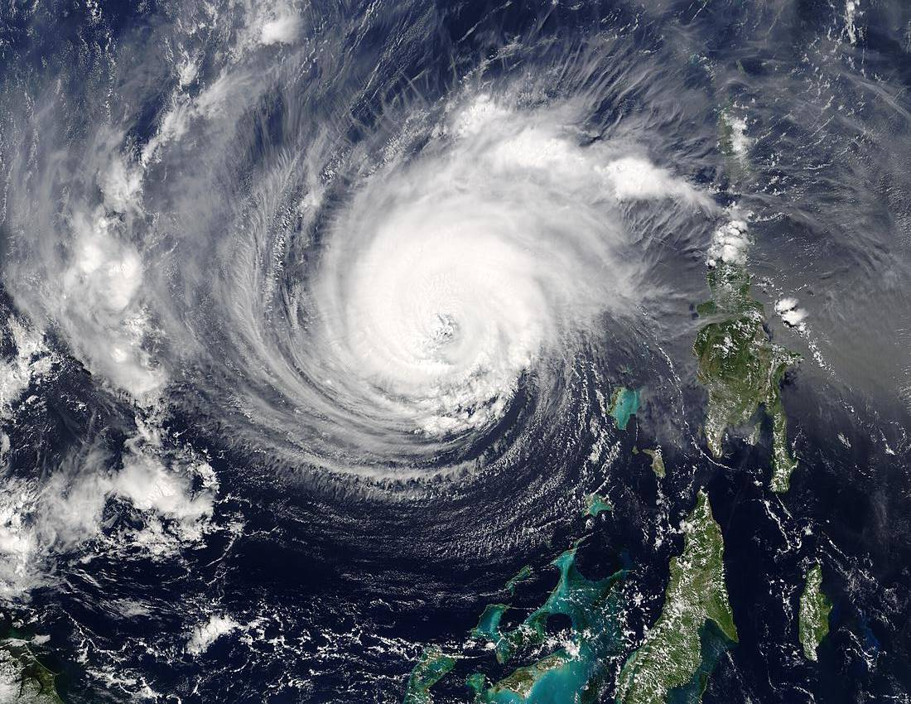

Hurr. Isabel 5/28/03

